TechM Logo.pngTech Mahindra Limited

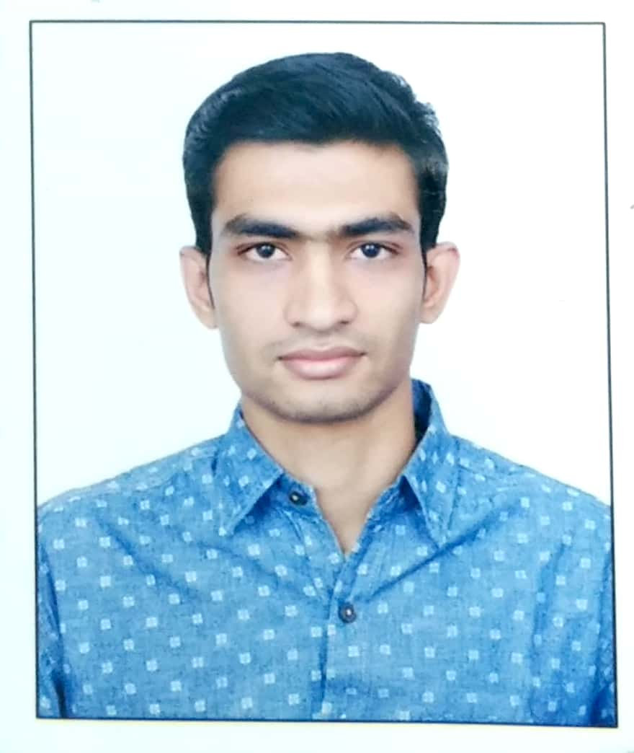

Please affix Passport-size Photograph here

Sharda Centre, Off Karve Road, Pune-411 004

## Application for Employment

**Personal Information**

Name Ranjit Kumar Patro

First / Given Name Middle Name Surname / Last Name

Name of Father Padma Patra Name of Mother Sunita Kumari Patra

Date of Birth 12/Jun/1993 Place of Birth Berhampur Marital Status Unmarried

Nationality: Indian Passport (PP) No: R3588765

Place of PP Issue: Bhubaneswar Dt. of PP Issue: 29/12/2017 Dt. of PP Expiry: 28/12/2027

If you don’t have a valid PP, have you applied for one? (pls use (√) mark for selection)

**No**

**Yes**

If have applied for PP, Application No: Dt. of Application: Have you ever been refused/denied visa any time? (pls use (√) mark for selection)

**(**√**)No**

**Yes**

If visa denied, give details:

|  |  |  |  |
| --- | --- | --- | --- |
| **Country** | **Type of Visa** | **Reason of Refusal/Denial** | **When Denied (date)** |
|  |  |  |  |
|  |  |  |  |
|  |  |  |  |

**Present Address** (PIN code mandatory)

Medical Bank Colony 5th lane, Bapuji Nagar, Berhampur, Ganjam, Odisha

Pin 760004

Landline Tel: Mobile No: 7019541594

**Permanent Address** (PIN code mandatory) (Write “Same as above” in case present and permanent addresses are same)

Medical Bank Colony 5th lane, bapuji nagar, Berhampur, Ganjam, Odisha

Pin 760004

Res. Tel: Mobile No: 7019541594

## E-mail:

Primary:ranjit25patro@gmail.com Secondary: ranjit18patro@gmail.com

**Signature of Applicant: ranjit kumar patro**

Do you have any relative(s) working with any of the Mahindra Group Companies including Tech Mahindra)? (pls use (√) mark for selection)

**(**√**)No**

**Yes**

If yes, please give details below: -

Name of Relative: Relationship: Name of Company:

Name of Relative: Relationship: Name of Company:

**Education Details** (Only those done through Govt recognized institutes/universities)

|  |  |  |  |  |  |  |
| --- | --- | --- | --- | --- | --- | --- |
| **Education** | **College/ University**  **(with Location)** | **Name of**  **Degree/ Level** | **Duration (MM/YY)** | | **Specialization** | **Percentage** |
| **From** | **To** |
| Matriculation/SSC/ Equivalent | Medical Campus, Berhampur | SSC | 08/2007 | 08/2008 | ENGLISH | 70 |
| Intermediate/HSC/ Equivalent |  |  |  |  |  |  |
| Diploma/ Equivalent | SCTEVT, Bhubaneswar | Diploma(IT) | 08/2008 | 08/2011 | INOFRMATION  TECHNOLOGY | 77 |
| Graduation/ Equivalent | BPUT, Odisha | BTECH | 08/2011 | 08/2014 | INFORMATION  TECHNOLOGY | 78 |
| Post-Graduation/ Equivalent |  |  |  |  |  |  |

# Employment History

(Need to cover gaps of more than 1 month in employments & education)

## Present/Current Employment

|  |  |  |  |  |
| --- | --- | --- | --- | --- |
| **Name of Employer: Vodafone India Services Pvt. Ltd** | **Industry Type**: Telecomm | | | |
| **Address: Pune** | **Period of Service (DD/MM/YY)** | | **Starting Salary** | **Current Salary** |
| **Reason for seeking change/leaving**: **Looking for professional and compensation growth** | **From** | **To** |
| 23/08/2018 | Till | 750000 | 1406000 |
| **Email & Ph. No.(s) of Employer** |
| **Your Current Designation** (as documented): Manager | **Name and Designation of Your Immediate Supervisor**:  **Karan Moza, Senior Manager** | | | |

**Previous Employment/ Jobs**

|  |  |  |  |  |  |  |
| --- | --- | --- | --- | --- | --- | --- |
| **S.**  **No.** | **Name and Address of Employer**  **(Please also give Telephone Nos.)** | **Emp Id (Must fill)** | **Period (DD/MM/YYYY)** | | **Designation** | **Last Salary Drawn**  **(Per Annum)** |
| **From** | **To** |
| 1 | Mavenir | 600507 | 29/Jan/2018 | 20/Aug/2018 | Member of technical  Staff 11-ops | 640000 |
| 2 | Auromax | AT/H/4001 | 06/Apr/2015 | 25/Jan/2018 | Associate | 320000 |
| 3 |  |  |  |  |  |  |
| 4 |  |  |  |  |  |  |
| 5 |  |  |  |  |  |  |

**Signature of Applicant: ranjit kumar patro**

|  |  |  |  |  |  |  |
| --- | --- | --- | --- | --- | --- | --- |
| **S.**  **No.** | **Name and Address of Employer**  **(Please also give Telephone Nos.)** | **Emp Id (Must fill)** | **Period (DD/MM/YYYY)** | | **Designation** | **Last Salary Drawn**  **(Per Annum)** |
| **From** | **To** |
| 6 |  |  |  |  |  |  |
| 7 |  |  |  |  |  |  |
| 8 |  |  |  |  |  |  |
| 9 |  |  |  |  |  |  |

## Professional References

|  |  |  |  |
| --- | --- | --- | --- |
|  | **Reference No 1** | **Reference No 2** | **Reference No 3** |
| **Name / Designation** | Sangeeta Patro/ Manager | Arpita Pattnaik/ Manager | Kirti Sahu/ Consulatation |
| **Email id and Mob. No.** | Sangeetapatro1997@gmail.com | Arpitapattanaik00@gmail.com | Kcsahu143@gmail.com |
| **Nature of Association** | Present employer colg. | Past Employer colg | Past Employer colg |

**General**

Have you ever applied for a job with any of the Mahindra Group Cos. in the last 6 months? If yes, give details:

**(**√**)No**

**Yes**

|  |  |  |  |
| --- | --- | --- | --- |
| **Name of Company** | **Position Applied For** | **Date of Application** | **Reason for Not Joining** |
|  |  |  |  |
|  |  |  |  |

**Salary expected: 19,00,000 /pa Joining Time required:3** (months)

Any additional information you feel relevant to your candidature:

I certify that:

# Declaration

1. The information furnished above is factually correct and subject to verification by Tech Mahindra Ltd.
2. All my education qualifications have been acquired from institutes duly recognized by Govt. established statutory authorities.
3. I accept that an appointment given to me can be revoked; if any of above information has been misstated or unstated.

ranjit kumar patro 21-01-2022 berhampur

**Signature of Applicant Date Place**

Tech Mahindra is an Equal Employment Opportunity Employer. It promotes and supports a diverse workforce at all levels in the Company. All qualified and eligible applicants will receive due consideration for employment without any regard to their race, religion, colour, gender, age, nationality, origin or disability. All applicants will be evaluated solely on the basis of their professional ability, competence, and requirement of the essential functions of the positions they have applied for.

## YOUR PRESENT EMOLUMENTS (ANNUAL)

|  |  |
| --- | --- |
| **Basic** | 492145 |
| **DA** | 387087 |
| **CCA** |  |
| **HRA** | 246072 |
| **Conveyance** |  |
| **LTA** | 60000 |
| **Any Other Allowances/ Payments**  (Pls specify here and below) |  |
| variable | 161767 |
|  |  |
|  |  |
| **Gross Income** | 1347071 |
| **PF** | 59057 |
| **Medical** |  |
| **Insurance** |  |
| **Any other Deductions**  (Pls specify here and below) |  |
|  |  |
|  |  |
| **Gross Deductions** | 59057 |
| **Net Salary per Annum** | 1406128 |

**Note**: You are free to modify the contents/components of your salary in the blank column and delete those listed above if not applicable to you.

Ranjit Kumar Patro

26-01-2022 Berhampur

**Signature of Applicant Date Place**